WIDE AREA NETWORK

Q1. Draw a simple diagram (on paper or using an online tool like draw.io) showing how your phone connects to Instagram's servers from your home WiFi, including the ISP and at least two Wide Area Network (WAN) devices (like routers or switches) in the path.
Ans.
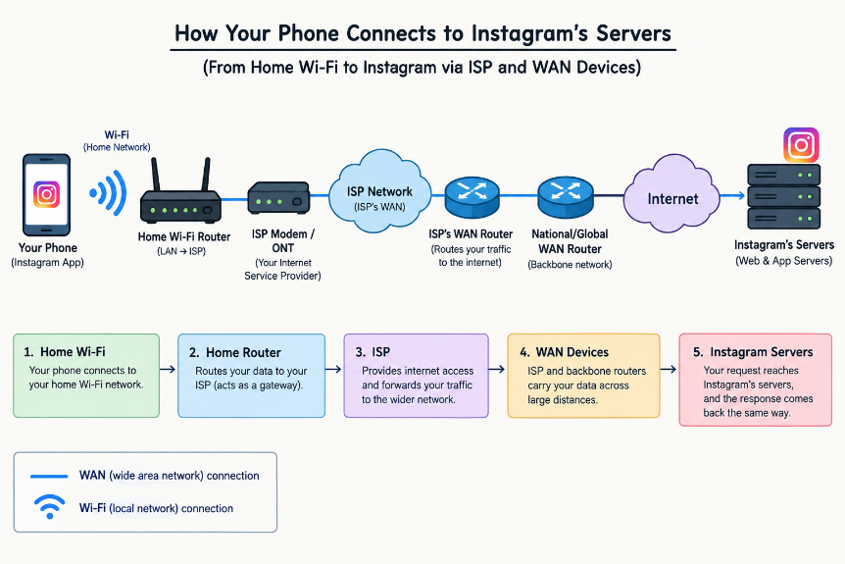
Q2. Create a table listing three types of WAN technologies (such as MPLS, Leased Line, and Broadband Internet) and compare them based on speed, cost, and where you might see them used in real life (e.g., Zomato office, IRCTC ticketing, your home).
Ans. WAN Technologies Comparison
WAN Technology | Speed | Cost | Real-Life Use
MPLS | High and reliable | High | Large companies such as a Zomato office connecting multiple branches
Leased Line | High and dedicated | Very High | Organizations such as IRCTC needing a dedicated connection between offices/data centers
Broadband Internet | Medium to high | Low | Home users accessing websites, streaming, and online services

Summary: MPLS and leased lines are commonly used when businesses need reliable, managed connectivity, while broadband is generally more affordable and suitable for homes and smaller offices.
Q3. Research and write a short explanation of how a VPN (Virtual Private Network) uses WANs to let you access apps like Spotify or YouTube securely from a public Wi-Fi at a coffee shop. Hint: Focus on how the VPN creates a private tunnel over the public WAN.

Ans. VPN and WAN – Short Explanation
- A VPN (Virtual Private Network) creates an encrypted private tunnel through the public WAN/Internet between your device and a VPN server.
- For example, when you use Spotify or YouTube on coffee-shop Wi-Fi, your data travels through the encrypted VPN tunnel, making it harder for people on the same public network to intercept the traffic. After reaching the VPN server, the traffic continues to the app’s servers over the Internet.
Q4. Imagine Flipkart wants to connect its warehouses in Ahmedabad, Mumbai, and Delhi. Suggest which WAN technology would be best for them and justify your answer with two reasons.
Ans. Recommended WAN Technology: MPLS
- Flipkart could use MPLS (Multiprotocol Label Switching) to connect its warehouses in Ahmedabad, Mumbai, and Delhi.
Two reasons:
- Reliable and consistent: MPLS provides dependable connectivity between different warehouse locations, which is useful for continuous data sharing.
- Secure and managed: Traffic can be separated and managed efficiently, helping protect warehouse systems and business data.

